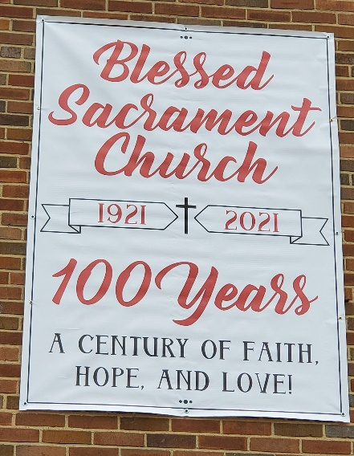
Welcome to our Centennial Anniversary year, 2021! Due to the current pandemic situation our activities will be guided by the Covid-19 guidelines.
With that said, we are in need of your help to recall the fun times, special services and spiritual growth you have experienced at Blessed Sacrament Church. We will have a bulletin section throughout the year, called Down Memory Lane, with shared memories, photos and stories. Please submit your contributions for this activity to the rectory with attention to Dc. Mike Colabufo.
During this Centennial year we are having time for spiritual growth every Thursday with Adoration and Benediction from 6:00 – 7:00 pm in church. Families and/or individuals are welcome to be the guardian of the Eucharist during Adoration by calling the rectory at (315) 437-3394 to sign up for a Thursday in 2021. The guardian arrives by 5:50 to stay in church with the Eucharist placed in the monstrance on the altar. This spiritual experience will include the recitation of the rosary, praying the Litany to St. Joseph, the Centennial prayer and Benediction conducted by Fr. Severine or one of the five deacons. Come join us each Thursday throughout 2021 for Adoration from 6:00 – 7:00 pm.
On the Third Sunday of Advent, we distributed a free copy of the book; Do Something Beautiful for God: The Essential Teachings of Mother Teresa. This daily reflection book is available to all Blessed Sacrament Church families or adult parishioners. To obtain your complimentary copy, please call the rectory to reserve a book for pick up during regular office business hours.
To celebrate the Centennial during the pandemic, we are offering face masks for $6.00 each. The masks have the logo 1921 Blessed Sacrament Church 2021, which come in red or white masks. Again, the masks are available at the rectory office.
Down Memory Lane: Our early history had a humble beginning. From a building that was at one time the Town Hall, dance hall and fire department horse barn, to a local barn beautified to become a chapel and soon enlarged to accommodate extraordinary growth in the congregation, to becoming the brick and block structure in which we worship together today. Life here has been blessed by the Lord for 100 years!
Up to 1921, St. Vincent DePaul in Syracuse and St. Matthew’s Church in East Syracuse served Catholics in the village of Eastwood. At that time the number of Catholics in the village was growing and Bishop Grimes recognized that the people of Eastwood needed their own parish. On September 12,1921 Bishop Grimes appointed Fr. Richard J. Shanahan as the first pastor and commissioned him to begin a new parish. The new pastor rented the Town Hall at 401 S. Midler Avenue for $15 per Sunday and began the parish on a cold, windy day of September 18, 1921 with a congregation of about 125 people. It was so difficult to find a sufficient sizeable piece of property to establish a new parish. The search process gave way to the purchase of six acres of land from Mrs. Laura A. Reynold for the sum of $22,000 on the First Friday in February, 1922. Fr. Shanahan desired to name the fledgling parish in honor of the Sacred Heart, but he couldn’t since there was another Sacred Heart Parish in Syracuse. His desire was to dedicate the new parish to the Holy Eucharist and finally he called it the Church of the Blessed Sacrament.
The purchased plot housed a barn and a family home which were transformed into the early church building and rectory. On September 3, 1922 the first Mass was offered in the new location. Though Catholics were not entirely welcomed in Eastwood in the early 1920’s and the presence of the Ku Klux Klan was demonstrated, the parish grew and in three years the barn chapel was doubled in size. Growth continued to exceed all expectations and Fr. Shanahan decided that a school and convent were needed before a church building.
From his experience at St. John the Evangelist Parish in Syracuse, Fr. Shanahan invited sisters of St. Joseph to staff the school. The community could spare no more than four nuns who opened the convent on August 31, 1931. The school began on the Feast of Mary’s Birthday, September 8, 1931 with a procession (so loved by Fr. Shanahan) including priests, sisters, parents and 168 initial students who comprised the first four grades. A grade was added each year until the parish celebrated with the first eighth grade graduation class in June, 1936.

Centennial Prayer (1921 – 2021)
of Blessed Sacrament Parish, Syracuse, NY
Gracious Father,
We your children humbly ask your blessing upon us as we celebrate a century of Faith, Hope and Love since the founding of our Blessed Sacrament Parish.
You have shaped us into a community where the dignity of each person is respected, where one can feel at home and worship you with joy and peace. By your grace we have responded to your call to bring all people into your family, the Church.
We desire to reach out to the least among us, to the poor, the marginalized and the alienated. As your faithful, we gather and are nourished by your Word and the Sacraments so that we may bring your love and healing to others.
Rooted in your Holy Spirit, may we face our future with the same faith, hope and vision of those who have preceded us, and may we commit ourselves to a new century of service.
Like the Holy Family of Nazareth, may we live humbly and simply
as instruments of your grace, your peace.
We make this prayer through the intercession of Our Blessed Mother, Mary, her husband, Joseph, and in the name of the One who is the same Yesterday, Today, and Forever – Jesus Christ, Our Lord.
Amen.
Submitted by Dc. Michael Colabufo January 17, 2021

